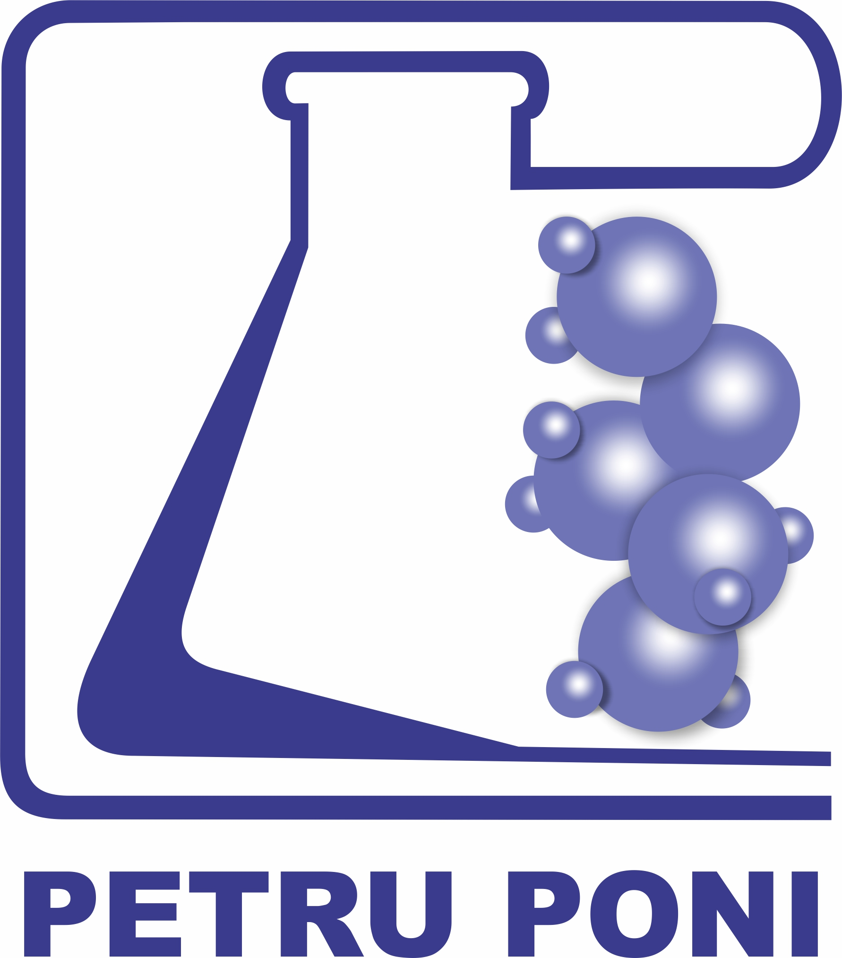 | ACADEMIA ROMÂNĂ  INSTITUTUL DE CHIMIE MACROMOLECULARĂ “PETRU PONI”  Aleea Grigore Ghica Vodă, nr. 41A, 700487 IAȘI, ROMÂNIA  Tel. +40.332.880220; Fax: +40.232.211299

COMPETITION ANNOUNCEMENT

"Petru Poni" Institute of Macromolecular Chemistry (Institutul de Chimie Macromoleculară „Petru Poni”, ICMPP), Iași, Aleea Gr. Ghica Vodă 41A, 700487, as Beneficiary, organizes the competition in order to hire within the funding contract no. 760284/27.03.2024, "Metal complexes for the treatment of cancer targeting microtubules or microtubules and R2 RNR (Metubin)", CF 99/31.07.2023, run through National Recovery and Resilience Plan, Component 9 “Support for the private sector, research, development and innovation”, Investment 8. "Development of a program to attract highly specialized human resources from abroad in research, development and innovation activities", call PNRR/2023/C9/MCID/I8, financed by the Recovery and Resilience Mechanism, several open positions, as follows:
- Position: Scientific researcher, degree II (experienced researcher)
Number of positions for competition: 1
Type of employment contract: individual part-time employment contract
Estimated contract start date: 05.08.2024
Period of employment: determined, at least until 31.12.2024, with the possibility of extension, financed by the project: Metal complexes as microtubule- and dual microtubule – R2 RNR-targeting drugs for cancer treatment (Acronym: Metubin) (ID 99/31.07.2023), Financing contract no. 760284/27.03.2024
The place of the research activity: the Laboratory of Inorganic Polymers within ICMPP
The venue of the competition: ICMPP, Aleea Gr. Ghica Voda 41A, 700487-Iasi, Romania.
Position description: synthesis, chemical modification, purification, and structural characterization of intermediates and final products in the preparation of organic ligands with indolobenzazocine structure.
Specific conditions for the position of scientific researcher grade II, CSII (experienced member-researcher):
- The candidate is an active, experienced researcher (acc. law 319/2003) with outstanding scientific performance in the field of organic synthesis, demonstrated by the originality and high international impact of scientific publications;
- The candidate is able to publish independently as the main author and contribute to the optimal performance of the research team's activities, especially with regard to doctoral students and post-doctoral researchers;
- Competences proven by diplomas, certificates, CVs, etc. in synthetic organic chemistry with emphasis on the synthesis and reactivity of heterocyclic compounds and the structural characterization of organic compounds, in general;
- Theoretical and/or practical knowledge in the fields of organic synthesis and pharmaceutical chemistry;
- Intermediate knowledge of a foreign language (English mandatory) and other international languages ​​are an advantage;
- The candidate must be available to travel within the country and abroad, if necessary;
- To be motivated and creative, with advanced communication and teamwork skills;
- Possess practical knowledge of computer operation (Word, Excel, Power Point, OriginLab).
Competition procedure:
1. Stage I – Analysis of the candidate's file (eliminatory): Only candidates who have submitted all the necessary documents to register for the competition and meet the conditions for participation are accepted to participate in the interview. The results are displayed with the mentions "admitted" or "rejected".
2. Stage II – Interview: will be held at the ICMPP headquarters, and will consist of a presentation of the original contributions obtained and the development perspectives in the job field. Each member of the competition committee will give marks between 1 and 10 individually. The final mark is the arithmetic mean of the marks awarded by each committee member. The ranking of candidates will be done according to the final average.

- Position: Scientific researcher degree III (Experienced researcher)
Number of positions for competition: 1
Type of employment contract: individual part-time employment contract
Estimated contract start date: 05.08.2024
Period of employment: determined, at least until 31.12.2024, with the possibility of extension, financed by the project: Metal complexes as microtubule- and dual microtubule – R2 RNR-targeting drugs for cancer treatment (Acronym: Metubin) (ID 99/31.07.2023), Financing contract no. 760284/27.03.2024
The place of the research activity: the Laboratory of Inorganic Polymers within ICMPP
The venue of the competition: ICMPP, Aleea Gr. Ghica Voda 41A, 700487-Iasi, Romania
Position description: design and synthesis of polydentate organic proligands and molecular assemblies of their metal complexes, their isolation in a crystalline state (single crystal), and their physico-chemical characterization.
Specific conditions for the position of scientific researcher grade III, CSII (experienced member-researcher):
- The candidate is an active, experienced researcher (acc. law 319/2003) with outstanding scientific performance, demonstrated by the originality and major international impact of scientific publications;
- The candidate is able to publish independently as the main author and contribute to the optimal performance of the research team's activities, especially with regard to doctoral students and post-doctoral researchers;
- Competences proven by diplomas, certificates, CVs, etc. in the field of organic, inorganic, and coordination chemistry, especially in the synthesis of polydentate organic proligands and assemblies of multifunctional mono- and polynuclear compounds with magnetic, electrical, catalytic, and biological properties;
  - Theoretical and practical knowledge in the synthesis and study of coordination compounds with various nuclearities;
  - Intermediate foreign language skills, English being mandatory; knowledge of other international languages ​​is an advantage;
- The candidate must be available to travel within the country and abroad, if necessary;
  - To be motivated and creative, with advanced communication and teamwork skills;
  - Have practical knowledge of computer operation (Word, Excel, Power Point, OriginLab).
Competition procedure:
1. Stage I – Analysis of the candidate's file (eliminatory): Only candidates who have submitted all the necessary documents to register for the competition and meet the conditions for participation are accepted to participate in the oral test. The results are displayed with the mentions "admitted" or "rejected".
2. Stage II – Oral test: will be held at the ICMPP headquarters. The evaluation of the oral test is expressed in marks from 1 to 10, being the average of the marks assigned to the candidates by each of the commission members. The final grade of the candidates is calculated with the following relation: final grade = file grade x 0.7 + interview sample grade x 0.3.
The ranking of candidates will be done according to the final average.
Topics:
1. Methods of synthesis and characterization of multifunctional organic compounds;
2. Methods of synthesis and characterization of azomethine, thioureic organic compounds, and their derivatives;
3. Synthesis and modeling of coordination compounds by the template assembly method;
4. Crystallization methods of two-phase systems for obtaining single crystals;
5. Spectral techniques for substance characterization and applications: FTIR, UV-Vis, mass spectrometry, ¹H-NMR, ¹³C-NMR, one- and two-dimensional correlations, single-crystal X-ray diffraction, SQUID, and RES interpretation.
References:
1. Francis A. Carey, Advanced Organic Chemistry, Springer, 2007, 1321 p.
2. Catherine E. Housecroft, Inorganic Chemistry 5th Edition, Pearson Higher Education; 5th edition (June 15, 2018), 416 p.
3. F. Albert Cotton, Geoffrey Wilkinson, Manfred Bochmann, Russell N. Grimes, Advanced Inorganic Chemistry: A Comprehensive Text 5th Edition, Wiley-Interscience; 5th edition (March 1, 1988), 1488 p.
4. N.V. Gerbeleu, V.B. Arion, John P. Burgess, Template Synthesis of Macrocyclic Compounds, Wiley-VCH; (August 11, 1994), 576 p.
5. R. Tilley, „Crystals and Crystal Structures”, John Wiley & Sons Ltd, Chichester, 2006

- Position of scientific researcher (postdoctoral member in the project)
Number of positions for competition: 1
Type of employment contract: individual part-time employment contract
Estimated contract start date: 05.08.2024
Period of employment: determined, until 31.12.2024, with the possibility of extension, financed by the project: Metal complexes as microtubule- and dual microtubule – R2 RNR-targeting drugs for cancer treatment (Acronym: Metubin) (ID 99/31.07.2023), Financing contract no. 760284/27.03.2024
The place of the research activity: the Laboratory of Inorganic Polymers within ICMPP
The venue of the competition: ICMPP, Aleea Gr. Ghica Voda 41A, 700487-Iasi, Romania.
Position description: recording and interpretation of ¹H, ¹³C, ²⁹Si, ¹⁹F, ³¹P spectra and ¹H-¹H, ¹H-¹³C or ¹H-¹⁵N two-dimensional correlations for the elucidation of the chemical structure of organic and coordination compounds, based on indolobenzazocine and thiosemicarbazones, through nuclear magnetic resonance-NMR.
Specific conditions for the position of scientific researcher (postdoctoral member in the project):
- The candidate must be a graduate of higher education with a bachelor's and master's degree in the field of chemistry and seniority acc. law 319/2003;
- The candidate holds a doctor's degree in chemistry field and falls within the definition of "post-doctoral researcher" according to Instruction no. 2260/15.11.2023 regarding the clarification of the notion of "post-doctorate" within the projects related to the investments of Component 9 "Support for the Private Sector, Research, Development and Innovation" of the National Recovery and Resilience Plan issued by the Ministry of Research, Innovation and Digitization: "the person who holds a doctor's degree and has experience in research of no more than 8 years full-time equivalent, from the date of the first doctoral degree, but not exceeding 10 years full-time equivalent under the conditions provided by the Executive Agency European for Research (REA)". *If the doctorate was awarded by ministerial order, the date of the ministerial order is taken into account, and otherwise, the date indicated on the diploma is taken into account; The date of the first doctoral degree is taken into account;
- The candidate must have advanced knowledge of the methods of physico-chemical characterization and structural identification/confirmation of organic compounds by NMR spectroscopy and a proven practical experience of at least 5 years in structural analysis by NMR;
- The candidate must have advanced knowledge in the use of NMR for structural identification/confirmation, and study of thiosemicarbazides, heterocyclic, and imine compounds;
- The candidate must have skills in processing and presenting the results;
- The candidate must have experience in writing scientific articles, at least in draft, and national/international project proposals. The candidate must have at least 5 papers published in journals with an ISI impact factor;
  - Intermediate foreign language skills, English being mandatory; knowledge of other international languages ​​is an advantage;
- The candidate must be available to travel within the country and abroad, if necessary;
- To be motivated and creative, with advanced communication and teamwork skills;
- Possess practical knowledge of computer operation (Word, Excel, Power Point). Knowledge of TopSpin, ChemDraw, MestReNova programs is an advantage.
Competition steps:
1. Analysis of the candidate's file (eliminatory): Only candidates who have submitted all the necessary documents to register for the competition and meet the conditions for participation are accepted to participate in the written test. The results of the selection of competition files are displayed with the mention "admitted" or "rejected".
2. Written test (eliminatory): it will be held at the ICMPP headquarters, with topics according to the announced theme. To be declared admitted, candidates must obtain a minimum grade of 8 (eight) in the written test. The results of the written test are displayed on the ICMPP website with the mention "admitted" or "rejected";
3. Oral test: it will be held at the ICMPP headquarters and will consist of the presentation of the scientific activity of the candidates. To be declared admitted, candidates must obtain a minimum grade of 8 (eight) in the oral test. The results of the oral test are displayed on the ICMPP website with the mention "admitted" or "rejected". The result of the competition tests is appreciated by each member of the commission with marks from 1 to 10; the grade of the test represents the arithmetic mean of the grades given by the committee members.
The final mark of the candidates is calculated with the following relation:
Final grade = written exam grade x 0.7 + oral exam grade x 0.3
The ranking of candidates will be done according to the final average.
Topics:
1. ¹H-NMR and ¹³C-NMR spectral techniques for the characterization of organic compounds and applications.
2. Two-dimensional correlation NMR spectral techniques.
3. Experimental aspects regarding the detection of other isotopes by NMR spectroscopy (²⁹Si, ¹⁹F, 31P, ¹⁵N)
4. Structural particularities of thiosemicarbazide derivatives.
5. Structural particularities of heterocyclic and imine compounds.
References:
1. I. Pogany, M. Banciu, Metode fizice în chimia organică, Ed. Ştiinţifică, Bucureşti, 1972.
2. H. Gunter, NMR Spectroscopy, Editura John Wiley & Sons, Chichester, 1980
3. L. D. Field, S. Sternhell, J. R. Kalman, Organic Structures from Spectra, Editura John Wiley & Sons, Chichester, 1995
4. H. Friebolin, Basic One- and Two- Dimensional NMR Spectrocopy, Editura VCH Verlagsgesellschaft, Weinheim, 1991
5. S. Berger, S. Braun, 200 and More NMR Experiments, Editura Wiley-VCH Verlag, Weinheim, 2004

- Position of scientific researcher (postdoctoral member in the project)
Number of positions for competition: 1
Type of employment contract: individual part-time employment contract
Estimated contract start date: 05.08.2024
Period of employment: determined, until 31.12.2024, with the possibility of extension, financed by the project: Metal complexes as microtubule- and dual microtubule – R2 RNR-targeting drugs for cancer treatment (Acronym: Metubin) (ID 99/31.07.2023), Financing contract no. 760284/27.03.2024
The place of the research activity: the Laboratory of Inorganic Polymers within ICMPP
The venue of the competition: ICMPP, Aleea Gr. Ghica Voda 41A, 700487-Iasi, Romania.
Position description: obtaining coordination compounds, crystallographic analysis, optimization, and modeling of structures by computational methods.
Specific conditions for the position of scientific researcher (postdoctoral member in the project):
- The candidate must be a graduate of higher education with a bachelor's and master's degree in the field of chemistry and seniority acc. law 319/2003;
- The candidate holds a doctor's degree in chemistry field and falls within the definition of "post-doctoral researcher" according to Instruction no. 2260/15.11.2023 regarding the clarification of the notion of "post-doctorate" within the projects related to the investments of Component 9 "Support for the Private Sector, Research, Development and Innovation" of the National Recovery and Resilience Plan issued by the Ministry of Research, Innovation and Digitization: "the person who holds a doctor's degree and has experience in research of no more than 8 years full-time equivalent, from the date of the first doctoral degree, but not exceeding 10 years full-time equivalent under the conditions provided by the Executive Agency European for Research (REA)". *If the doctorate was awarded by ministerial order, the date of the ministerial order is taken into account, and otherwise, the date indicated on the diploma is taken into account; The date of the first doctoral degree is taken into account;
- The candidate must have advanced knowledge of organic chemistry (Schiff bases, acids, and esters), inorganic chemistry (different metal complexes), as well as the usual characterization techniques;
- The candidate must have skills in acquiring and processing data obtained by single crystal X-ray diffraction using different programs such as CrysAlisPro, Olex2, Platon, ORTEP, ShelX, Sir2019, Diamond4 (for viewing);
- The candidate must have skills in molecular modeling;
- The candidate must have experience in writing scientific articles, at least in draft. The candidate must have at least 5 papers published in journals with an ISI impact factor;
  - Intermediate foreign language skills, English being mandatory; knowledge of other international languages ​​is an advantage;
- The candidate must be available to travel within the country and abroad, if necessary;
- To be motivated and creative, with advanced communication and teamwork skills;
- Possess practical knowledge of computer operation (Word, Excel, Power Point). Knowledge of ChemDraw, Origin, MestReNova, ChemSketch, ImageJ, ACD Spectrus Processor, Match and crystallographic databases is a plus.
Competition steps:
1. Analysis of the candidate's file (eliminatory): Only candidates who have submitted all the necessary documents to register for the competition and meet the conditions for participation are accepted to participate in the written test. The results of the selection of competition files are displayed with the mention "admitted" or "rejected".
2. Written test (eliminatory): it will be held at the ICMPP headquarters with topics according to the announced theme. To be declared admitted, candidates must obtain a minimum grade of 8 (eight) in the written test. The results of the written test are displayed on the ICMPP website with the mention "admitted" or "rejected";
3. Oral test: it will be held at the ICMPP headquarters and will consist of the presentation of the scientific activity of the candidates. To be declared admitted, candidates must obtain a minimum grade of 8 (eight) in the oral test. The results of the oral test are displayed on the ICMPP website with the mention "admitted" or "rejected". The result of the competition tests is appreciated by each member of the commission with marks from 1 to 10; the grade of the test represents the arithmetic mean of the grades given by the committee members.
The final mark of the candidates is calculated with the following relation:
Final grade = written exam grade x 0.7 + oral exam grade x 0.3
The ranking of candidates will be done according to the final average.
Topics:
1. Methods of synthesis and characterization of multifunctional organic compounds;
2. Methods of synthesis and characterization of organic azomethine compounds and their complex combinations;
3. Usual compound purification techniques;
4. Spectral techniques for substance characterization and applications: FTIR, UV-Vis, mass spectrometry, ¹H-NMR, ¹³C-NMR, X-ray diffraction (single crystal and powder).
References:
1. C.D Nenițescu, Chimie organică, Ediția a VIII-a, Editura Didactică și Pedagogică, București, 1980, vol. 1, 2.
2. M. Avram, Chimie organică, Editura Academiei Române, București, 1983, vol. 1,2.
3. F. Badea, Mecanisme de reacție în chimia organică, Editura Științifică, București, 1973.
4. R. Tilley, „Crystals and Crystal Structures”, John Wiley & Sons Ltd, Chichester, 2006
5. R.M. Silverstein, F.X. Webster, D.J. Kiemle, Spectrometric Identification of Organic Compounds, 7th edition, John Wiley&Sons, Inc., 2005.

- Position of research assistant (PhD student member in the project)
Number of positions for competition: 1
Type of employment contract: individual part-time employment contract
Estimated contract start date: 05.08.2024
Period of employment: determined, until 31.12.2024, with the possibility of extension, financed by the project: Metal complexes as microtubule- and dual microtubule – R2 RNR-targeting drugs for cancer treatment (Acronym: Metubin) (ID 99/31.07.2023), Financing contract no. 760284/27.03.2024
The place of the research activity: the Laboratory of Inorganic Polymers within ICMPP
The venue of the competition: ICMPP, Aleea Gr. Ghica Voda 41A, 700487-Iasi, Romania
Position description: synthesis, purification, and structural characterization of indolobenzazocine organic intermediates and ligands;
Specific conditions for the position of research assistant (PhD student member in the project):
- The candidate must be a graduate of higher education with a bachelor's and master's degree in the field of chemistry and be enrolled in a doctorate program at an institution organizing doctoral studies in Romania, in the field of chemistry;
- Theoretical and practical knowledge in the fields of fine organic chemistry and organic structural analysis;
- Theoretical and practical knowledge in the field of heterocycle chemistry;
  - Intermediate foreign language skills, English being mandatory; knowledge of other international languages ​​is an advantage;
- The candidate must be available to travel within the country and abroad, if necessary;
- To be motivated and creative, with advanced communication and teamwork skills;
- Possess practical knowledge of computer operation (Word, Excel, Power Point). Knowledge of ChemDraw, Origin, MestReNova, ChemSketch, and ImageJ is a plus.
Competition procedure: file analysis and oral test - presentation of the scientific activity of the candidates. Only candidates who have submitted all the necessary documents to register for the competition and meet the conditions for participation are accepted to participate in the oral test. The results of the selection of competition files are displayed with the mention "admitted" or "rejected". The oral exam will take place at the ICMPP headquarters. Each member of the competition committee will individually award grades between 1 and 10. The final grade is the arithmetic mean of the grades awarded by each member of the committee. The ranking of candidates will be done according to the final average.
Topics:
1. Methods of synthesis and characterization of multifunctional organic compounds;
2. Methods of synthesis and characterization of organic azomethine compounds and their complex combinations;
3. Common techniques for the purification of organic and coordination compounds;
4. Spectral techniques for substance characterization and applications: FTIR, UV-Vis, mass spectrometry, ¹H-NMR and ¹³C-NMR.
References:
1. C.D Nenitescu, Chimie organica, Editia a VIII-a, Editura Didactica si Pedagogica, Bucuresti, 1980, vol. 1, 2.
2. M. Avram, Chimie organica, Editura Academiei Romane, Bucuresti, 1983, vol. 1,2.
3. F. Badea, Mecanisme de reactie in chimia organica, Editura Stiintifica, Bucuresti, 1973.
4. R.M. Silverstein, F.X. Webster, D.J. Kiemle, Spectrometric Identification of Organic Compounds, 7th edition, John Wiley&Sons, Inc., 2005.

Note: These positions are open to all applicants, regardless of race, religion, gender or sexual orientation, and the project team rejects any type of discrimination.

Competition timetable:
Competition publication date: 26.06.2024
Deadline for file registration: 26.07.2024, 12.00 HR Office, first floor, ICMPP;
email: balan.catalina@icmpp.ro
Publication on the institute website of the results of the file analysis: 26.07.2024, 16.00
Deadline for appeals on the results of the file analysis: 29.07.2024, 14.00
Publication on the institute website of the final results of the file analysis: 29.07.2024, 16.00
For the positions of scientific researchers in grades II (CSII) and III (CSII):
Oral examination (interview): 30.07.2024, 11.00.
Publication on the institute website of the results of the oral examination: 30.07.2024, 16.00
Deadline for appeals on the results of the oral examination: 31.07.2024, 14.00
Publication on the institute website of the final results: 31.07.2024, 16.00
For the positions of scientific researchers (postdocs):
Written test: 30.07.2024, 09:00 at the Institute headquarters;
Date of publication on the institute website of the results of the written test: 30.07.2024, 16:00 Deadline for appeals on the results of the written test: 31.07.2024, 14:00
Publication on the institute website of the final results on the written test: 31.07.2024, 16:00;
Oral examination (interview): 01.08.2024, 11.00;
Publication on the institute website of the results of the oral examination: 01.08.2024, 14.00
Deadline for appeals on the results of the oral examination: 01.08.2024, 16.00
Publication on the institute website of the final results: 02.08.2024, 14.00
For the position of research assistant (PhD student):
Oral examination (interview): 01.08.2024, 09.00;
Publication on the institute website of the results of the oral examination: 01.08.2024, 14.00
Deadline for appeals on the results of the oral examination: 01.08.2024, 16.00
Publication on the institute website of the final results: 02.08.2024, 14.00.

General requirements for candidates:
- The candidate has Romanian citizenship, citizenship of other member states of the European Union, or citizenship of states belonging to the European Economic Area;
- The candidate knows written and spoken Romanian and/or English;
- The candidate has full exercise capacity;
- The candidate has a state of health corresponding to the position for which he/she is applying;
- The candidate is medically fit;
- The candidate is available for part-time employment for a fixed period.

The registration file must contain the documents provided by Art. 15 para. (6) of Law No. 319/2003 regarding the Statute of Research and Development Personnel, namely:
- The candidate's application should be addressed to the ICMPP legal representative, requesting registration for the competition for filling the vacant position. The request should be dated and signed by the candidate, approved by the legal representative of the institute, and registered within the legal deadline for registration;
- Copy of the identity document and copies of documents certifying the change of name, if applicable;
- Copies of the documents certifying the candidate's studies: bachelor's and/or master's degree accompanied by the transcript(s);
- Diplomas obtained in other countries must be recognized by The National Center for the Recognition and Equivalence of Diplomas (CNRED), and implicitly by the National Council for Attestation of University Titles, Diplomas, and Certificates in Romania (CNATDCU) or initiate the steps for them;
- Certificate attesting to the quality of a doctoral student enrolled in an institution organizing doctoral studies in Romania for the positions of research assistant - doctoral student;
- Appendix 9 – PhD supervisor's agreement (model displayed on the website) completed and signed for the position of research assistant - PhD student;
- Doctor's diploma, for the positions of scientific researcher grade II, grade III (experienced researchers), and scientific researcher - post-doctoral student;
- Curriculum vitae adapted to employment requirements;
- List of scientific contributions accompanied by copies of the papers (if appropriate);
- Cover letter (free format), indicating the research areas of interest and the motivation for applying to this vacant position;
- Original medical certificate attesting clearly to the state of health, containing the number, date, name, of the issuer, in the standard format established by the Ministry of Health;
- Criminal record or declaration on own responsibility that has no criminal convictions that would make it incompatible with the position for which the candidate is applying, with the completion of the competition file (up to the date of the first competition test) and the original criminal record.

The candidate undertakes to maintain the confidentiality of the research topics in which he participates.

Details regarding the specific conditions can be read on the website https://icmpp.ro, the Vacancies section, https://www.euraxess.gov.ro/ro, https://jobs.research.gov.ro/, or additional information can be obtained at the Human Resources Office at the headquarters of the "Petru Poni" Institute of Macromolecular Chemistry Iași, telephone 0332 880 220.

This announcement was published on the website of the Institute - Section "Vacancies", by the Secretary of the Competition Commission on 26.06.2024

